Social Media Guide for DSD Sites

The Community Food and Agriculture Coalition has created social media content to help you promote Double SNAP Dollars this season. Please feel free to copy and paste these templates, personalize them, and use the recommended hashtag list as you see fit! Please provide any feedback you may have to bridget@missoulacfac.org, as we are always trying to improve our marketing materials.

Graphic | Example caption
Graphic 1  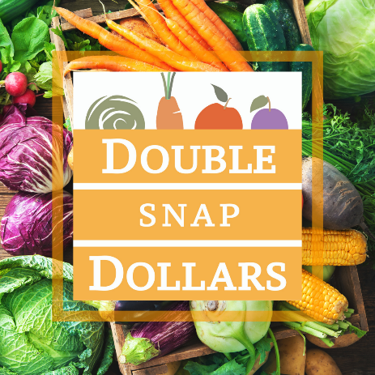 | For every $1 you spend in SNAP at our market, we’ll match you $1 free in Double SNAP Dollars to spend on fruits and vegetables. Get up to $30 free per person per day! Double SNAP is a win-win-win for farmers, families, and the local economy!  Bring your SNAP/EBT card to our market info booth to get your extra Double SNAP Dollars!
Graphic 2  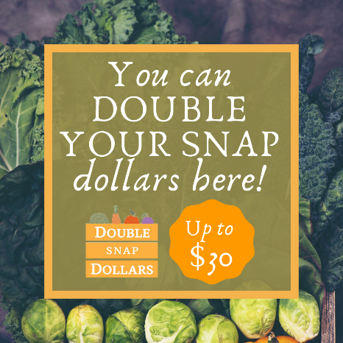 | You can stretch your SNAP dollars even further at our market! How?? Through the Double SNAP Dollars program! For every $1 you spend in SNAP, receive a $1 match to spend on fruits, veggies, and plant starts! Get up to a $30 match per person per day!  Bring your SNAP/EBT card to our market info booth to start shopping!
Graphic 3  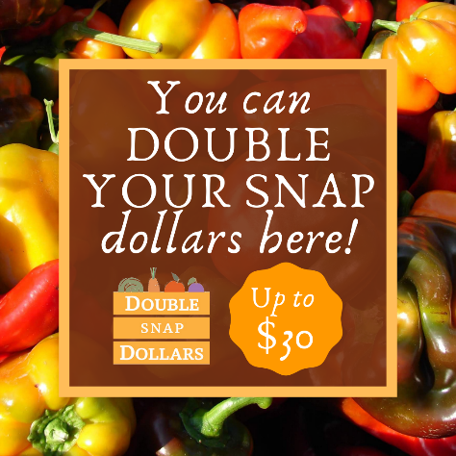 | DOUBLE your purchasing power at our market with Double SNAP Dollars! We’ll match your SNAP spending up to $30 per person per day, and you can use these extra Dollars to buy additional fruits, veggies, and plant starts.  Bring your EBT card to our market info booth--we’ll get you all set up to start shopping!
Graphic 4  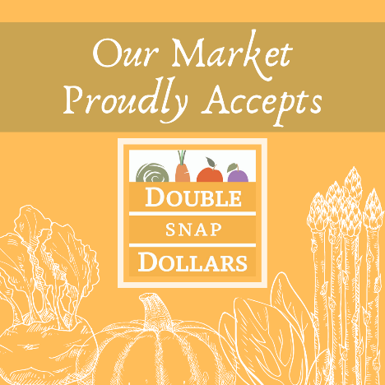  Graphic 5  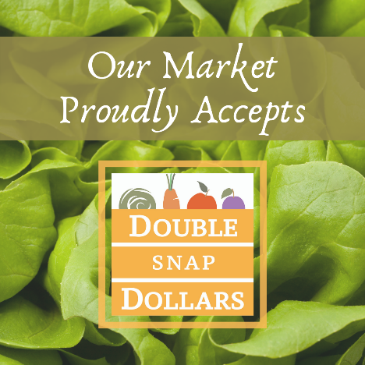 | We are proud to offer SNAP and Double SNAP Dollars at our market! For every $1 you spend in SNAP, we will match you an additional $1 FREE to spend on fruits and veggies—up to a $30 match per day!  Bring your SNAP/EBT card to our market info booth before you shop. Hope to see you soon!
Graphic 6  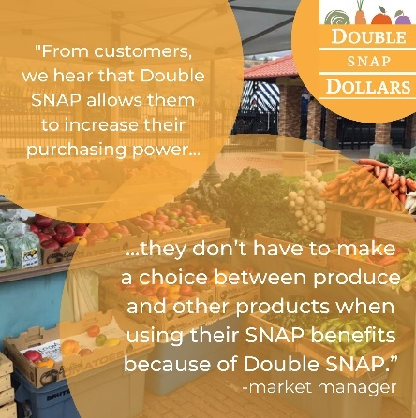 | Double SNAP Dollars is customer-approved! Increase the purchasing power of your SNAP benefits at the farmers market! For every $1 in SNAP that you spend at our market, we’ll match an additional $1 free (up to $30) in Double SNAP Dollars for fruits, veggies, and plant start purchases—making it easy to get more nutritious foods to your family!  Bring your SNAP/EBT card to our market info booth to get started!
Graphic 7  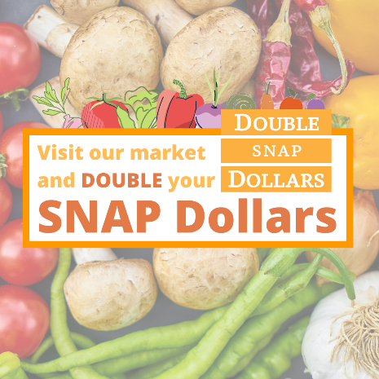 | Get FREE fruits and vegetables at our market with Double SNAP Dollars! SNAP customers receive an extra Double SNAP Dollar for every SNAP dollar they spend—that’s up to $30 free to spend on fresh fruits and veggies!  Bring your EBT card to our market info booth and DOUBLE your purchasing power! Hope to see you soon!
Graphic 8  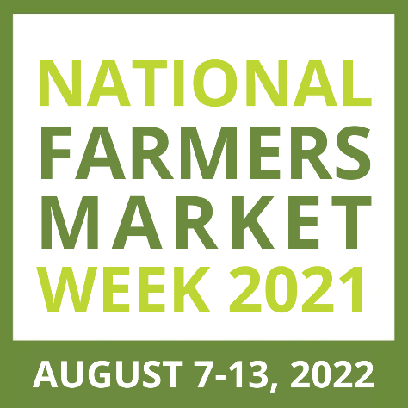 | Happy National Farmers Market Week! Celebrate by visiting your favorite market (that’s us!) We’re so grateful to our community—you’ve shown us so much support and we’ve felt celebrated all season long!  And a quick reminder—we proudly accept SNAP and Double SNAP Dollars, meaning every dollar you spend in SNAP, you’ll get an additional $1 free to spend on fresh fruits and vegetables. (Up to $30 per person per day!) Another reason to celebrate!  See you all at the market soon!
Recommended Tags & Hashtags: | Tag the Double SNAP Dollars Instagram account filled with more info about the program: @doubledollarsmt  Hashtags:  #farmersmarket #farmersmarketfresh #farmfresh  #farmfreshproduce #doublesnapdollars #montanagrown #farmerstofamilies #food4all #eatlocal #supportlocal #supportfarmersmarkets #supportfarmers #knowyourfarmer #community #localfoodheroes  During National Farmers Market Week (August 7-13, 2022): #NationalFarmersMarketWeek

